Elementary Spanish
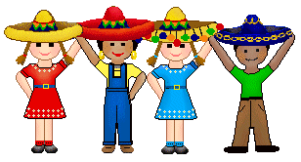
Henry Barnard School
Week 27
Grade: PreK/ K
Topic: La letra Q/ ¿Qué o Quién es? (Review)
Objectives: | - To learn to pronounce the letter “Q”  - To learn about Quito and other words/ cultural items that begin with the letter “Q”  - To review all letters of the alphabet learned so far  - To review all content learned so far  - To read books that combine vocabulary words
Standards: | 1.11, 1.12, 1.13, 1.14, 1.15, 1.21, 1.22, 1.23, 1.24, 1.25, 1.31, 1.32, 1.33, 2.11, 2.12, 4.11, 4.12, 4.13
Materials: | - Flyswatters  - Subject cards  - Memory cards  - Bubbles  - Bingo boards  - “Q” Power Point presentation
Introduction: | Begin with the opening greeting/ song (“¡Hola niños! ¿Cómo están? Buenas tardes a ti- song”). Review all letters of the alphabet learned so far. Learn about the letter “Q” with Power Point.
Development: | Play games to review all material learned so far. Games include: flyswatter game, bubble pop, memory/ matching game, bingo. Practice answering the questions, “¿Qué es” and “¿Quién es?
Activities: | Games  Songs (opening and closing)
Assessment: | Recall of all material learned so far
Homework: | Review all letters and games played so far
Content: Review of all topics since last review: Classroom objects, sports, house, places, clothing, giving directions, numbers, commands, and professions; learning about the letter “Q”.

