Elementary Spanish
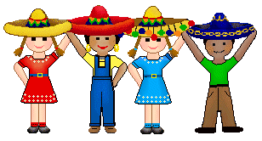
Henry Barnard School
Week 12
Grade: PreK/ K
Topic: Review
Objectives: | - To review all letters of the alphabet learned so far  - To review all content learned so far  - To read books that combine vocabulary words
Standards: | 1.11, 1.12, 1.13, 1.14, 1.15, 1.21, 1.22, 1.23, 1.24, 1.25, 1.31, 1.32, 1.33, 2.11, 2.12, 4.11, 4.12, 4.13
Materials: | - Flyswatters  - Subject cards  - Memory cards  - Bubbles  - Bingo boards
Introduction: | Begin with the opening greeting/ song (“¡Hola niños! ¿Cómo están? Buenas tardes a ti- song”). Review all letters of the alphabet learned so far.
Development: | Play games to review all material learned so far. Games include: flyswatter game, bubble pop, memory/ matching game, bingo.
Activities: | Games  Songs (opening and closing)
Assessment: | Recall of all material learned so far
Homework: | Review all letters and games played so far
Content: Review of all topics covered so far: Conversation, colors, numbers, dates, body parts, prepositions, family members, farm animals, and telling time.

